**INTERNSHIP REPORT**

**STUDY OF THE**

**ORACLE EBS ERP**

**AT**

**TITAN COMPANY LIMITED**

**JEWELLERY DIVISION**

**SITUATED AT HOSUR, TAMIL NADU**

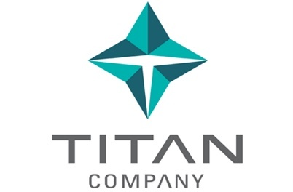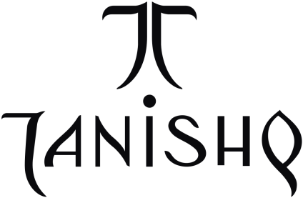

**BY**

**Ms. R. ASWATHAMAN**

**(711316104013)**

**DEPARTMENT OF COMPUTER SCIENCE AND ENGINEERING**



**KPR INSTITUTE OF ENGINEERING AND TECHNOLOGY**

(Approved by AICTE, New Delhi, Affiliated to Anna University, Chennai-25,

Accredited by NBA (CSE, ECE, EEE & MECH and NAAC with ‘A’ Grade,

An ISO 9001:2015 and ISO 14001:2015 Certified Institution,

DSIR Certified Scientific and Industrial Research Organization)

Coimbatore - 641 407

**ACKNOWLEDGEMENT**

I am grateful to **Dr. N. YUVARAJ Ph.D.,** Head, Department of Computer Science and Engineering for providing us with necessary facilities during the course of work.

I would like to express my heartfelt sincere thanks to our beloved Internship Coordinator **Dr. N. PRASATH Ph.D.,** Associate Professor, Department of Computer Science Engineering for rendering his fullest guidance and support during the course of study and project.

I would like to express my heartfelt thanks to our chief mentor**Mr. K. KAMARAJ** Associate Professor, Department of Computer Science Engineering and our beloved mentor **Mr. R. SIVARAMAKRISHNAN** Assistant Professor, Department of Computer Science Engineeringfor their guidance.

I wish to extend our gratitude to all faculties of our department, our friends and our parents for their valuable suggestions for successful completion of our project.

I would also like to thank Titan Company Limited for providing me an opportunity to

do this project in the Department of Information Technology. I wish to extend my gratitude to**Mr. T. N.KRISHNAMURTHY** (Manager IT). This project would have not been possible without the guidance and great help from**Mr.S.SUBRAMANIAN** (Titan Company Limited - Jewellery division) and also**Mr. ROHIT NAGAR** (Titan Company Limited - Jewellery division) who has provided me with the functioning of the departments, the policies, procedures and other modes of operation adopted in the departments without which the completion of this project would not be possible. This made my fact-finding process easier and knowledgeable.

Last but not the least, I would like to thank each and every individual for their sincere help and support that has largely contributed to the successful completion of the project.

CONTENTS

OVERVIEW OF TATA 4

HISTORY OF TATA 5

CONSOLIDATION: 1932-1989 6

TATA COMPANIES 7

ORIGIN OF TITAN COMPANY LIMITED 7

TITAN JEWELLERY DIVISION (BRANDS) 11

TANISHQ 14

DEPARTMENT OF INFORMATION TECHNOLOGY 15

ORACLE E-BUSINESS SUITE 16

ENTERPRISE RESOURCE PLANNING (ERP) 17

A SIMPLE ERP PROCESS FLOW 20

ROLE OF THE DEPARTMENT 20

FUNCTIONS OF INFORMATION TECHNOLOGY DEPARTMENT 22

MANUFACTURING PROCESS 23

FLOW OF ORACLE PROCESS MANUFACTURING-PRODUCTION MANAGEMENT 24

ORACLE PROCESS MANUFACTURING (OPM) MODULES 25

ORACLE PRODUCTION MANAGEMENT 25

ORACLE PURCHASING 26

ORACLE ORDER MANAGEMENT 27

ORACLE PROCESS MANUFACTURING COSTING 27

ORACLE INVENTORY 28

ORACLE ACCOUNTS RECEIVABLE 28

ORACLE ACCOUNTS PAYABLES 29

ORACLE GENERAL LEDGER 30

CURRENT PROJECT 30

# OVERVIEW OF TATA

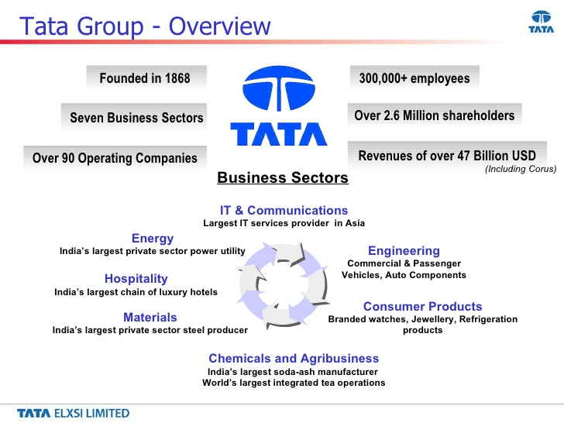

* There are 29 publicly-listed Tata enterprises, which include Tata Steel, Tata Motors, Tata Consultancy Services, Tata Power, Tata Chemicals, Tata Global Beverages, Tata Teleservices, Titan, Tata Communications and Indian Hotels. The group has a combined market capitalisation of around $103.51bn (2016-17).
* Tata companies have made significant investments in different geographies. With our ever-increasing international footprint, we are now reaching out to customers in the farthest corners of the world.
* We touch upon lives across the globe and we have an employee strength of over 660,800 employees, representing the rock-solid company that we are.
* Several Tata Group companies have achieved leadership positions globally in their areas of operation.

The Tata Group's value system directs the growth and business of all sectors we operate in. Two-thirds of the equity of Tata Sons, the Tata group holding company, is held by philanthropic Trusts that have created national institutions for science and technology, medical research, social studies and the performing arts.

# HISTORY OF TATA

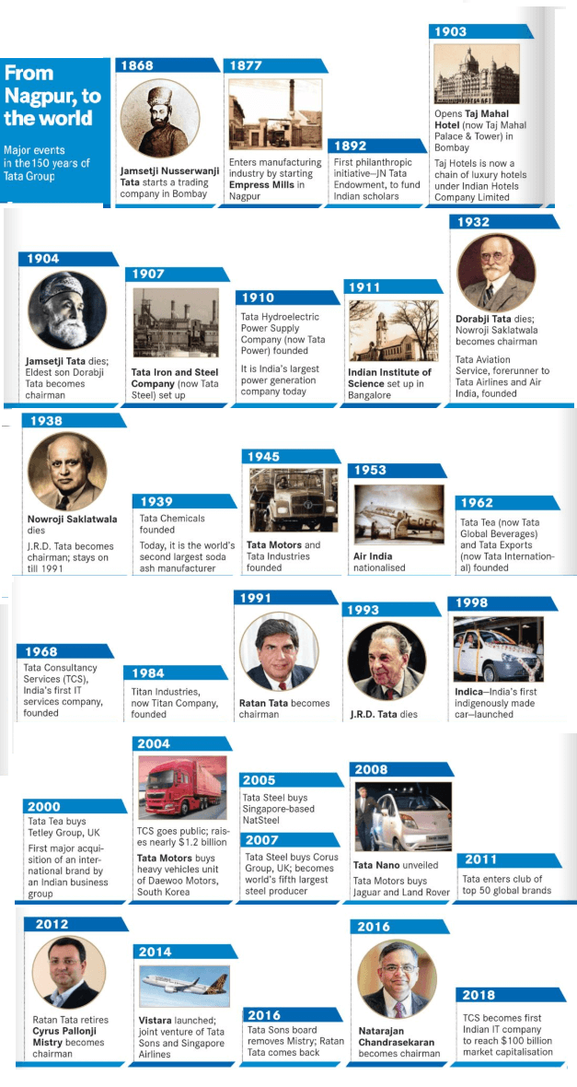

# CONSOLIDATION: 1932-1989

**Change of guard**

By the time of Sir Dorab Tata’s death in 1932, the Tata group had consolidated its businesses while also getting in new areas, notably insurance and the production of soaps, detergents and cooking oil. **Sir Dorab** was succeeded as chairman of the Group by Sir Nowroji Saklatwala. In 1938, following Sir Nowroji’s demise, 34-year-old JRD Tata (left) was appointed as the new chairman. He would lead the Tata group for the next 53 years - with wisdom, foresight and a rare grace that touched everyone he met.

**JRD’S passion**

The first of JRD Tata’s big moves in business was born of a childhood fascination for flying. In 1929, he became one of the first Indians to be granted a commercial pilot's license. In 1932, Tata Aviation Service, the forerunner to Tata Airlines and Air India, India’s national carrier, took to the skies. The maiden flight in the history of Indian aviation took off from Drigh Road in Karachi, now in Pakistan, with JRD Tata at the controls of a Puss Moth. In 1953, the Indian government nationalized Air India.

**New beginnings**

During the more than five decades that JRD Tata was at the helm, the Tata group expanded regularly into new spheres of business. The more prominent of these ventures were **Tata Chemicals (1939)**, **Tata Motors** and **Tata Industries(both 1945)**, **Voltas (1954)**, **Tata Tea [(1962)** now known as **Tata Global Beverages, Tata Consultancy Services (1968)** and **Titan Industries (1984).**The post-independence era in India, right up to the early 1990s, was a time of tight government controls on business, but despite this the Tata group managed to grow considerably.

# TATA COMPANIES

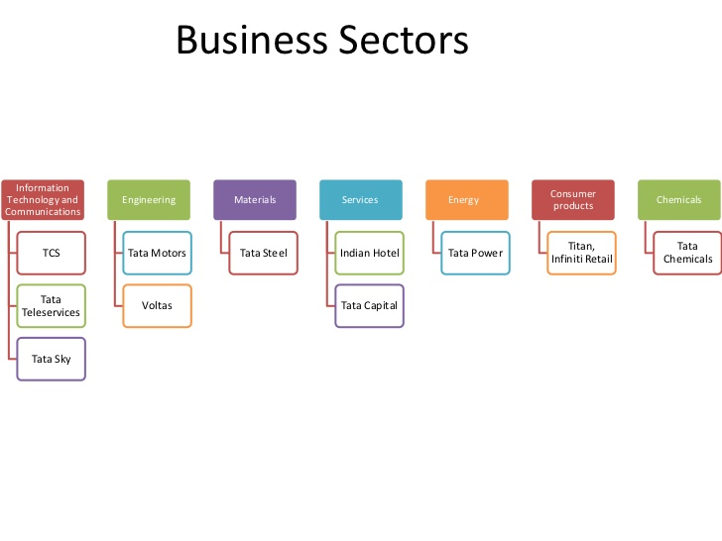

# ORIGIN OF TITAN COMPANY LIMITED

Started in the year 1984, Titan Company consists of four business divisions namely Watch and Accessories (WAD), Jewellery (JD), Eyewear (EWD) and Precision Engineering (PED). The Jewellery business, being a consumer complex and competitive business constitutes around 80% of the revenue for Titan Company Limited

Tanishq, being part of Titan Company Limited (Formerly Titan Industries) was promoted by the Tata group in collaboration with the Tamil Nadu Industrial Development Corporation (TIDCO) and started its operations in the year 1994 The Tanishq Jewellery Division is having their own manufacturing plants and one of the factory is located in Hosur, Tamil Nadu with approximately an area of 1,35,000 sq.ft and it has established itself as one of the trustworthy jewellery brands of India in gold, diamond and platinum jewellery. In addition, there are three other units – one located in Dehradun and one in Pantnagar (Uttarakhand) and one more in Sikkim and the regional operations are in Kolkata, Mumbai, Jaipur & Delhi

The name “Tanishq” originates from a combination of two words “Tan” meaning body and “Nishq” meaning gold ornament. Tanishq propagates ethical practices and provides the customer a certification of purity of material and reselling policies. Following the line of ethical practice further, adequate policies are in place for the artisans who create the jewellery.

There are more than 70 vendors connected across the country with ERP systems which provides better visibility, tracking and controlling of the inventory as well as the orders and others like TOC (Theory of Constraints), Product catalogue and others. Oracle EBS is the IT backbone of Jewellery Division catering to all major processes such as procurement, sourcing, production, distribution, costing, payables, receivables and general ledger. Oracle and other IT applications enable Jewellery business to fulfil business growth, enhance customer experience, improve operational efficiencies, and adhere to legal and statutory compliances.

The Jewellery manufacture by Tanishq has currently penetrated with more focus into the Indian market as compared to earlier where most of the production was aimed at exports being made to the European and American markets. The main production covered is manufacture of Jewellery watches and Jewellery ornaments including ornaments made of diamonds and other precious gem stones along with plain Jewellery.

Tanishq is having a blend of traditional values along with a modern outlook and being one of the most important Tata brand for the company as well as for the Jewellery market in India which is aimed towards understanding the needs and desires of Indian women.

In the year 2005, the company launched the Jewellery line “GoldPlus” chain of stores which is targeting mainly the semi-rural and rural population of India having more traditional designs keeping in mind the requirements of 22-carat gold wedding jewelleries.

A rigorous process for jewellery research takes place in Tanishq and has a very strong client base in terms of purchases made from merchants and other suppliers for raw materials.

Over the years, it has a wide collection of Jewellery targeting different customers in the domestic as well as the international market. The two main seasons for the company is in the month of April to May during Akshayatritiya festival and in the month of November to December during Diwali festival.

The Karigars at Tanishq are provided with world-class facilities having a safe and supportive environment and are provided with benefits like health care and financial aid and because of the advancement in jewellery making equipment and technology, the workers also gain training and access to the top of the line machines to aid them in the creation of their management and the unit also complies with the labor and environment standards.

Recently, Tanishq has taken up special projects and included designer jewellery made for Bollywood movies such as Paheli and Jodha Akbar

The Jewellery products are retailed through a network of around 122 exclusive Tanishq boutiques and 29 Goldplus boutiques in more than around 100 towns in India mainly in Maharashtra, Andhra Pradesh, Karnataka and Tamil Nadu. There are about 70 service centres and 30 service facilities for the after sales services across the country.

There has been news from the personnel that the GoldPlus chain is gradually getting merged into the brand Tanishq itself. Around 80% of all the stores across the country for Watches and Accessories, Jewellery, and Eyewear divisions are run by franchisees.

VISION:  
We create **elevating experiences** for the people we touch and**significantly impact the world** we work in

MISION:  
We will do this through a **pioneering** spirit and a **caring, value-driven culture** that fosters **innovation**, drives **performance** and ensures the **highest global standards** in everything we do.  
VALUES AND STANDARDS:

1. **Total customer orientation:**   
   Customers take precedence over all else, always.
2. **Employee appreciation:**  
    We value and respect Titanians and endeavour to fulfil their needs and aspirations.
3. **Performance culture and teamwork:**  
    At Titan Company, high performance is a way of life and is nurtured by teamwork.
4. **Creativity and Innovation:**  
    Driven by innovation and creativity, we focus on smarter approaches and newer technologies.
5. **Passion for excellence:**  
    In all our pursuits, we ceaselessly strive for excellence.
6. **Corporate Citizenship:**  
    We ensure that a part of our resources is invested in environment and community betterment.

**AWARDS & ACCOLADES:**

**Corporate**  
• Selected as Best Employer for "National Award for the Empowerment of Persons with Disabilities - 2014" by Government of India  
• Titan ranked among the 100 most sustainable corporations in Asia in the Channel News Asia Sustainability Ranking 2014.  
• "Champion of Champions" award at the 8th Loyalty Summit for the Encircle Loyalty Program. 2014  
• Top Indian Company award under the Gems and Jewellery Sector at the Dun & Bradstreet Corporate awards, 2014  
**Watches**  
• Award at the CII 24th Kaizen national awards for assembly casing team  
• "Good Design Award 2014" by design Council of Japan for Skeletal Edge  
• Bronze medal at the Indian Effies Award for FastTrack  
**Jewellery**  
• "Most Admired retailer of the year" award in Jewellery Category by Images Retail Awards.  
• Tanishq wins Global Awards for Excellence in Quality Management & Leadership by World Quality Congress.  
• Tanishq is the first Indian Brand to enter the list of top 30 Best Retail Brands in Asia Pacific and stands at # 13 as per Interbrand.  
**Eyewear**  
• Award for Customer service excellence at Golden Globe Tigers Award.  
• Gold & Silver Awards at TRRAIN (Trust for Retailers and Retail Associates of India) Retail Awards.  
• Gold Award in the Outdoor Advertising Convention 2014.

**Precision Engineering**  
• Precision Engineering, Hosur wins three State Safety Awards announced by Tamil Nadu Government for 2013.

# TITAN JEWELLERY DIVISION(BRANDS)

TANISHQ:

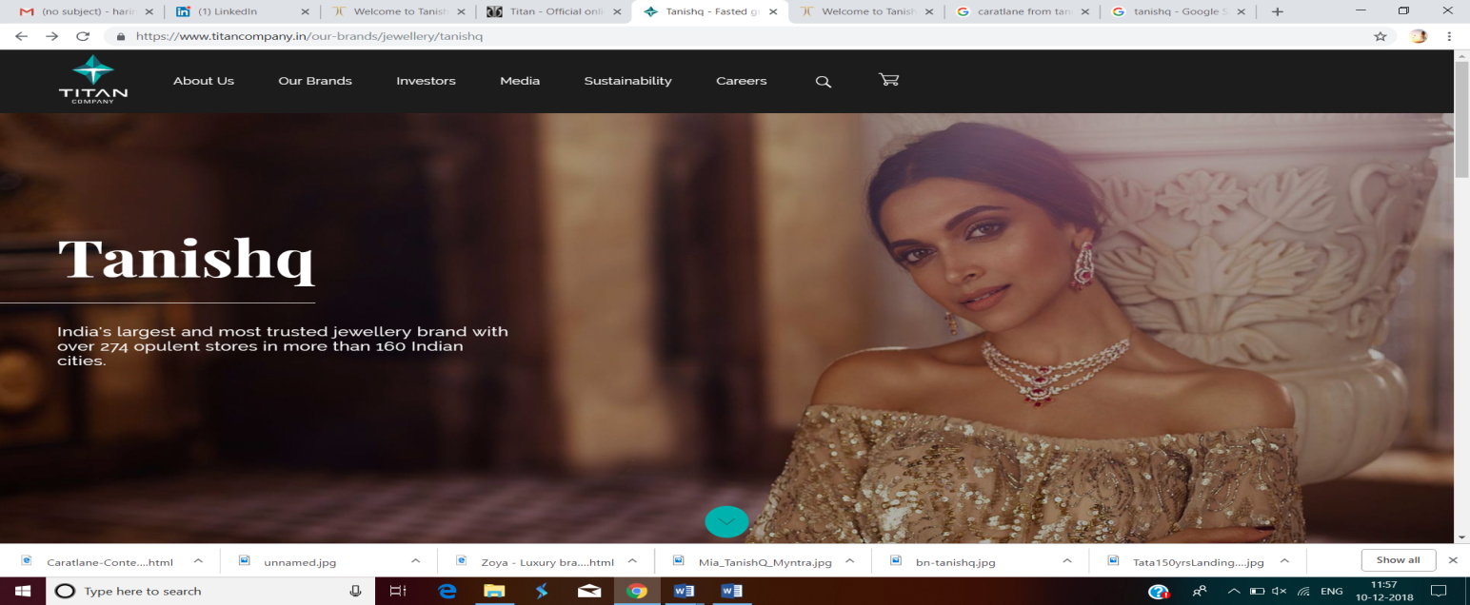

The journey of Tanishq started with the launch of 18k gold watches studded with precious stones in 1994. But, it soon grew into a 22K jeweller who presented an exquisite range of gold and diamond jewellery while striking a perfect balance between traditional appeal and contemporary charm. The brand perfectly understands the ethos of the current Indian jewellery market and keeps evolving along with its changing demands and preferences.Tanishq has brought to the market a whole new standard of business ethics and product reliability, in the process bringing about a transformation in which jewellery is bought or sold in India. Not only does it abide by the stringent standards but also adheres to strict and uniform guidelines across all 274+ stores in 160+ cities.

MIA:

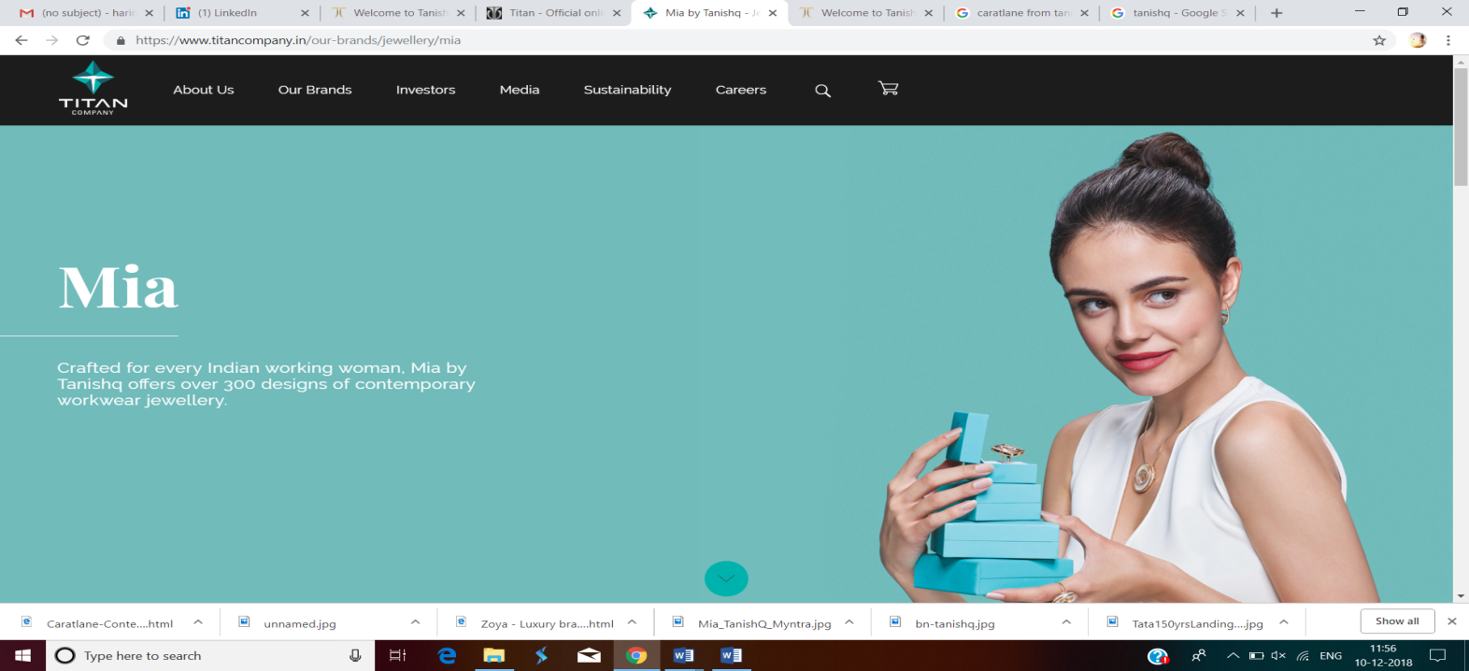

Born with the heritage and the legacy of Tanishq, Mia is a brand of modern and chic jewellery for the young and the stylish, the bold and the experimental. Mia by Tanishq crafts fine jewellery for the Mia woman's everyday, in designs that are unique, minimal and extremely versatile. Featuring a wide range of pendants, rings, bracelets and earrings, the collections from Mia are designed to accessorize the woman of today, for every moment and every occasion, taking her from desk to dinner with ease. Mia fine jewellery combines authentic designs with quality materials to deliver pieces that are effortless and timeless.

ZOYA: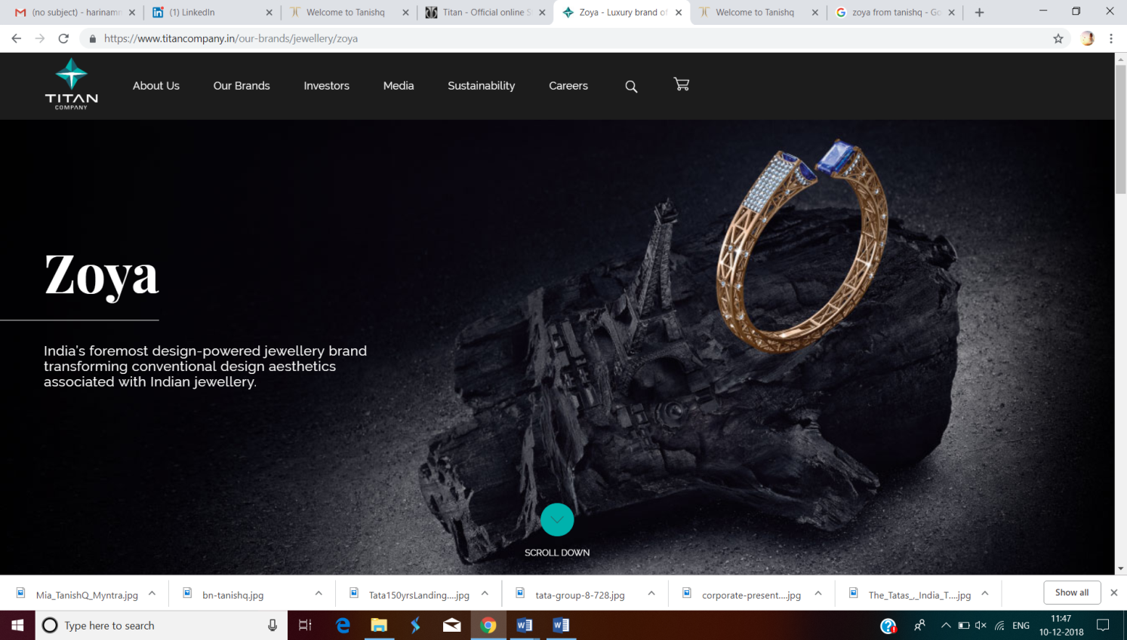

Zoya has carved a niche for itself in the world of haute joaillerie or high jewels, with a reputation for unique inspiration, superlative design, finest materials, and outstanding craftsmanship. These pillars of the brand merge to make every Zoya jewel distinctive, exclusive, and coveted. Its distinctive style, drawing inspiration from around the world and producing jewels that combine the most beautiful gemstones with quality craftsmanship have elevated the jewels to works of art.

CARATLANE:

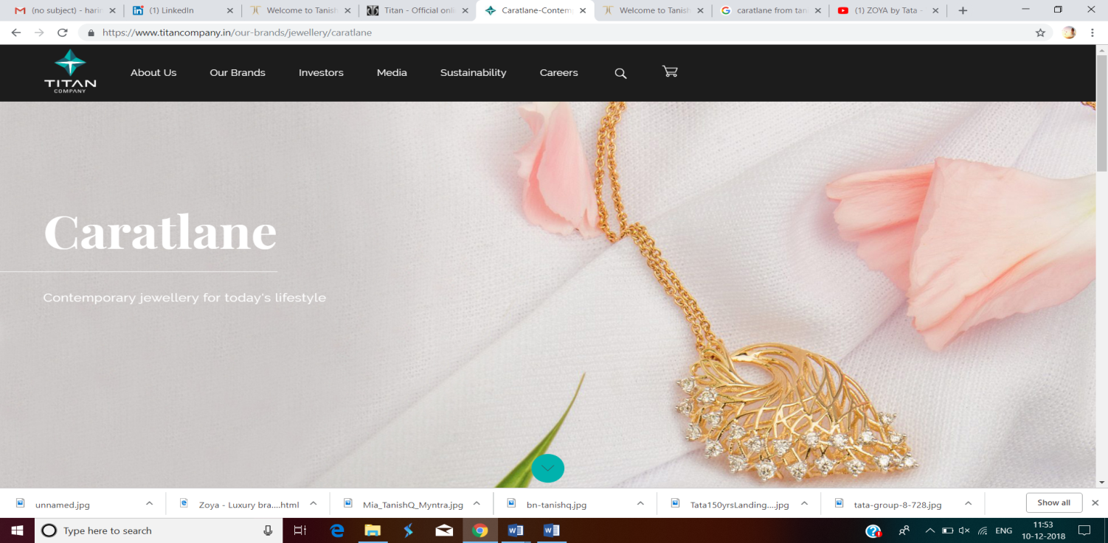

Founded in 2008 by Mithun Sacheti and Srinivasa Gopalan, CaratLane is an omnichannel brand which makes contemporary jewellery that is affordable, accessible and forever wearable. Currently, CaratLane operates 16 retail stores across Delhi, Mumbai, Thane, Bengaluru, Chennai, Hyderabad, Pune, Chandigarh and Coimbatore. It also has an online shopping website [caratlane.com](https://www.titancompany.in/www.caratlane.com), wherein customers can browse through a wide catalogue of designs and shop for anything that they like.

# TANISHQ

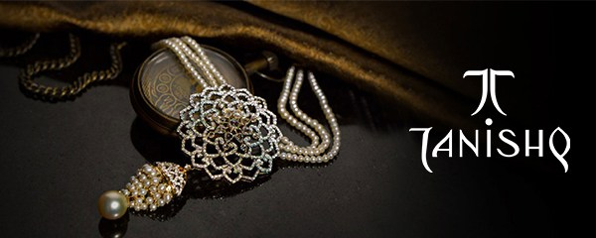

OUR PHILOSOPHY

*A collective passion for art and architecture inspires the team at Tanishq to bring a fresh perspective to the intricate, time-honoured craftsmanship of each meticulously handwoven creation.*

Tanishq Titan's flagship line of jewellery is today a resounding success with discerning customers. Tanishq has performed exceedingly well and has set standards, in what could best be described as a largely unorganised and unscrupulous Indian jewellery market.  
The growth of the brand has once again been a testament to our customer focus. Tanishq is today a hallmark of trust, an island of purity. It is a certified division under the ISO 9001:2008 Quality Management System Standards and the current version of Environment Management System Standard is ISO 14001:2004. Tanishq is India's fastest growing jewellery brand with a premium range of jewellery, studded with diamonds or coloured gems in 18 kt gold, 22 kt pure gold and platinum jewellery. We are now one of India's largest speciality retailers and are transforming India's jewellery market with a pan - India presence. Titan felt a need and created a means to offer elegant gold jewellery to smaller towns and rural markets. The recent launch of a retail initiative - Goldplus caters to the need. Both brands contribute to over Rs.2000 million USD, and are still flourishing. Truly a phenomenon Tanishq is our pioneering Indian brand storming a market of over 400,000 independent jewellers.

The brand is evolving faster than the market and is either leading or closing gaps between competitors in urban markets where we have a presence. The trust connotations that the Tata - Titan association evokes, never fails to attract increasing numbers of jewellery seekers to the fledgling designer brand. Titan ensures that they are spoilt for choice, transparency and a great shopping experience with Tanishq, the jewel of its crown.  
Tanishq is a trustworthy, popular jewellery brand from India's largest integrated jewellery manufacturer. **Zoya**, by Tanishq is a chain of luxury jewellery boutiques which targets elite, discerning ladies seeking designer wear of international standards. Zoya is a best-in-class shopping experience. Stores offer exquisite, artistically styled masterpieces, studded in diamonds, apart from traditional, fusion polki and kundan jewellery. There are magnificent designs to choose from, all in ultra-premium luxury, these outlets showcase luxury unsurpassed. **Zoya** creations are world-class in terms of quality and have been crafted in India and abroad. It boasts the finest quality in India and is on par with the best in the world. Zoya stores are in two cities, Delhi and Mumbai in India.

# DEPARTMENT OF INFORMATION TECHNOLOGY

The information technology department in the organization focuses on the constant monitoring of the software packages used in the industry to ensure that there are no hindrances caused in the process and to ensure effective software utilization among all the departments. Each division in the company consists of different software usage. In the Jewellery division, till 2005 July they were using a small ERP package that was developed Inhouse using **UNIX**-shell scripting. From July 2005 to December 2011 they were using **ORACLE** 11i (E-Business Suite), then form December 2011 to till date they have been using **R12**(E-Business Suite) version 12.1.2. Currently they are in the process of upgrading to 12.2.6 which is now an industry standard and a stable version.

The Boutiques which are the final outlet for sale of jewellery uses the software POSS (Point of sale system) where the details of the sales are recorded. After the day sales and other details are recorded in the POSS, the information is sent to E-POSS (Enterprise POSS) which receives the consolidated information from all the boutiques and is processed for further usage and data flown back to oracle ERP.

# ORACLE E-BUSINESS SUITE

Oracle E-Business Suite is the most comprehensive suite of integrated, global business applications that enable organizations to make better decisions, reduce costs, and increase performance.

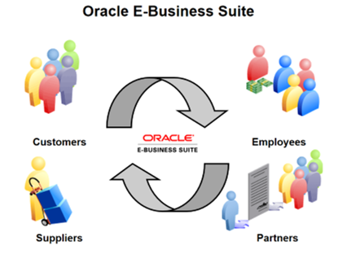

Benefits of Oracle E-Business Suite

* Oracle E-Business Suite supports multiple languages, all currencies, and many regulatory requirements in a single database. You can install all languages in the same Unicode instance. Trading partners can receive business documents in a language of their choice; users can view and enter dates, numbers, and currencies in a format they prefer. There is no separate version of the EBS for the U.S., Japan, or France.
* Oracle EBS is the first and only comprehensive set of enterprise applications that is integrated around a single, common data model. The unified information architecture of Oracle EBS enables consolidation of data from Oracle and non-Oracle applications, and allows a consistent definition of customers, suppliers, partners, employees, and all business entities across the enterprise. You can create a single, global definition that allows everyone (worldwide) to have access to the same data. The single, common data model ensures that accurate and consistent information and transaction flows across all applications.
* Oracle EBS extends internal process support beyond enterprise boundaries to include customers, suppliers, and other trading partners. Linking your enterprise with your customers and suppliers offers global visibility and enables bidirectional flow of business information.

# ENTERPRISE RESOURCE PLANNING(ERP)

**Meaning of ERP:**

ERP is a package software solution that addresses the enterprise needs of an organization by tightly integrating the various functions of an organization using a process view of the organization.

Need of ERP:

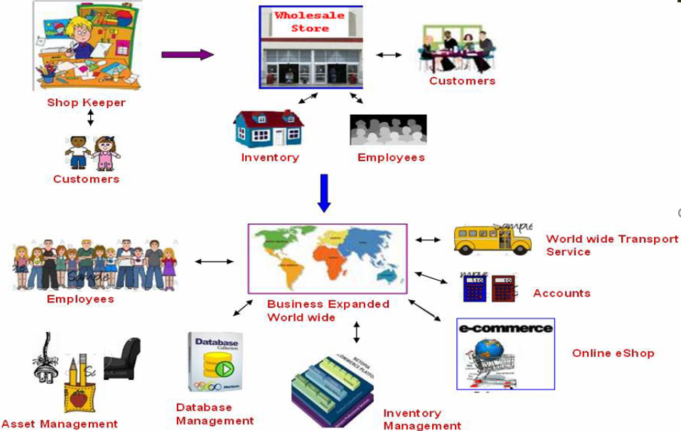

Role of ERP

**Stage-1**

1. **Daily Job:**
2. Collect goods from vendor.
3. Sell items/goods to customers.
4. If any goods out of stock note it down to order it from vendor.
5. Daily accounting - Profit & loss.

**Stage-2**: After a year your business is developed & you are becoming a whole sole dealer.

1. **Changes in Business**
2. Many branches.
3. Hire People for working.
4. Maintaining a small database for the business.
5. Transportation services.
6. **Daily Job:**
7. Collect goods from vendor & store it in inventory.
8. Take order from shop keepers.
9. Maintain small database for goods, shopkeepers & employees.
10. Using a computer for accounting. & Delivering items to customers.

**Stage-3**

* 1. **Changes in business**

1. Worldwide Branches and customers.
2. Developed as a Multinational Organization.
3. International Transportation.
4. Ecommerce, Phone marketing. etc.
   1. **Workload in business**
5. Now the owner of the business cannot go to sites (all over the world) daily.
6. He must maintain a big database for his business to run continuously.
7. Need to manage inventory activities (how much is sold, received items etc.).
8. Need to maintain the employees and their benefits (Needs HR team).
9. Need to calculate accounting (profit & loss for worldwide business).
10. Asset management.

# A SIMPLE ERP PROCESS FLOW

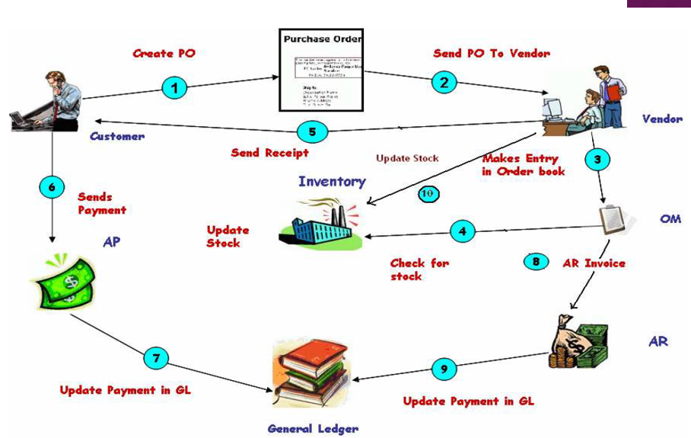

# ROLE OF THE DEPARTMENT

The delivery head, heads the section that runs certain critical IT applications such as Oracle ERP, TOC Symphony for Frontend and back end Operations, Plan Visage – Plain, Plan Visage – Studded, Product Catalogue, Barcode Application, IMS Application, SEED application and other NET applications.

1. **Head of the department (Roles):**
2. The head is the in charge for timely Replenishment recommendation for the entire value chain of Integrated Supply Chain Management and enable for timely supply to ensure availability in Retail outlets throughout the year as the divisional strategic goals are highly dependent on the IT System and solution.
3. The head also manages other critical IT applications such as Plan Visage – Plain, Plan Visage – Studded, Product Catalogue, Barcode Application, IMS Application. SEED Application and other .NET applications.
4. Enable and facilitate senior management to drive strategic initiatives to attain business goals.
5. Identify and meet strategic needs such as Business process design, facilitate process improvements and automations, Rollouts to facilitate business expansions, build and design Process controls to comply with Statutory and Audit governance framework within and across SBU’s.
6. **Head of the department (Responsibilities)**
7. Collaborate and drive organizational strategic programs through IT projects with internal and external teams, which is virtually networked.
8. Enable and facilitate business division to drive organizational strategic initiatives.
9. Enable every strategic function to achieve their goals through seamless and robust operations in mission critical IT applications.
10. Co-create with external and internal stakeholders such as leading IT consulting services / firms to develop World Class business solutions.
11. Technological Scan of external environment and recommend innovative solution for operational excellence.
12. Enable and implement IT functional strategies for organizational development.

# FUNCTIONS OF INFORMATION TECHNOLOGY DEPARTMENT

1. **Data base admin**

Data base admin includes tasks such as managing data base servers, server space utility, system performance, form server and report server

1. **Functional**

Functional includes understanding the business requirements and redesigning the standard functionality to meet the requirements.

1. **Technical**

Technical includes understanding the functional requirements in the form of designing of forms and procedures as per the coding standards in terms of the functional specification.

**Instances in information technology**

1. **Development instance**

It is used by technical developers to develop forms, procedures, packages as per the functional specification and 1 testing (initial testing) is done by the developers and preliminary testing by respective functional consultants

1. **Testing instance**

It includes complete and thorough testing by functional consultants as per the design/functional specifications and end-user testing and sign-off for production deployment

1. **Production instance**

It is live instance used for day to day transactions.

# MANUFACTURING PROCESS

Information Technology in Tanishq uses **Oracle Process Manufacturing (OPM).**

**Oracle Process Manufacturing(OPM)** An ERP system for the process manufacturing industry from Oracle that runs on a variety of computers. It provides more than a dozen integrated modules for research and development, manufacturing, distribution, customer service and financial activities. Oracle Process Manufacturing (OPM) was originally **Global Enterprise Manufacturing Management System (GEMMS)**, first developed by Datalogix. Oracle renamed the product after it acquired Datalogix in 1997.

**Challenges faced by the process manufacturing**

The following two critical Challenges faced by a Process manufacturing organization and the ways to address them using OPM are dealt with.

* **Regulatory requirements**
* **Operational excellence**
* **Regulatory requirements**

**Regulatory requirements** in a Process manufacturing industry can be achieved by implementing the following best practices. Track your Materials efficiently so that they can be recalled at any point in time during the manufacturing process. This can be achieved by leveraging OPM features shown in the figure below. These features not only enable your organization to track your Materials but also address your Regulatory and Compliance requirements.

* **Operational Excellence**

**Operational Excellence** is an element of organizational leadership and organizational intelligence that focuses on meeting customer expectation, all while stressing the application of a variety of principles, systems, and tools toward the sustainable improvement of key perfo

rmance metrics.

# FLOW OF ORACLEPROCESS MANUFACTURING-PRODUCTION MANAGEMENT

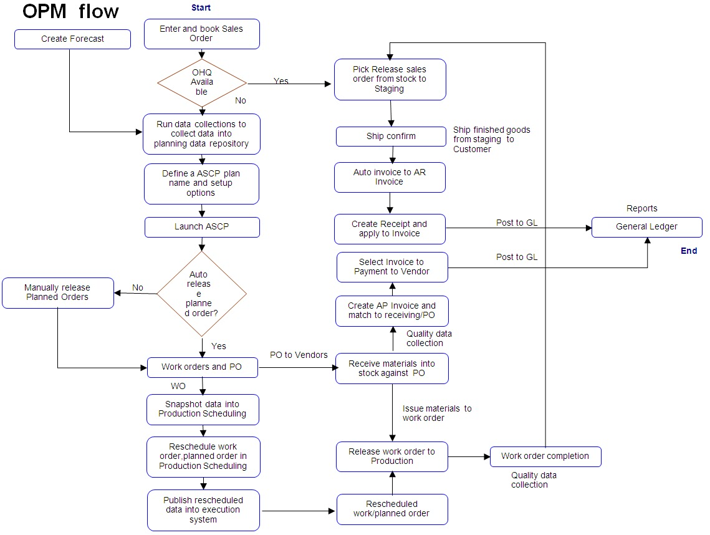

# ORACLE PROCESS MANUFACTURING (OPM) MODULES

They are:

* Oracle Production Management
* Oracle Purchasing
* Oracle Order Management
* Oracle Process Manufacturing Costing
* Oracle Inventory
* Oracle Accounts Receivable
* Oracle Accounts Payable
* Oracle General Ledger

# ORACLE PRODUCTION MANAGEMENT

There are various types of production. They are:

1. **In-House**
2. **Job work**
3. **Outwork**
4. **In- House**: Goods manufactured in the factories of Hosur, Pant Nagar, Sikkim are termed as inhouse production. This generally means production is done within the factories.
5. **Job Work**: Semi finished components for e.g.: cast trees, stones, etc ate sent in the form of a kit to the Job Worker who then performs necessary activities like stone setting, polishing etc to convert the semi-finished component to a finished good form. For this the Job Worker is paid labour charges as per agrees terms with Titan Company Limited.
6. **Out Work:** In case of out work raw or Alloyed Gold is sent to the out worker for further processing and conversion to the finished goods. The out worker is paid labour charges for the activity he performs as per agreed term with Titan Company Limited.

# ORACLE PURCHASING

Oracle Purchasing is the application for professional buyers that streamlines purchase order processing while strengthening policy compliance. It is a key component of Oracle Advanced Procurement.

Per independent experts the key to achieving world class procurement performance lies in using technology to automate routine tasks. This frees procurement professionals to work on more strategic tasks related to sourcing and supplier management. Oracle Purchasing does just that. It automates purchasing to make buyers more productive, improves management of your supply base, and adapts to virtually any procurement process.

As the heart of the Oracle Advanced Procurement suite, Oracle Purchasing provides a rich store of policy and supplier information, an enterprise class automation platform, and a robust workbench for buying professionals. Oracle Purchasing is part **of**[**Oracle Advanced Procurement**](http://www.oracle.com/us/products/applications/ebusiness/procurement/051329.html) suite, and integrates seamlessly with other Procurement applications, including IProcurement**,**[**Payables**](http://www.oracle.com/us/products/applications/ebusiness/financials/054001.html)**,** and I Supplier portal .

# 

# ****ORACLE ORDER MANAGEMENT****

Oracle Order Management improves the entire ordering and fulfilment process across the order-to-cash lifecycle. Increase customer satisfaction and order profitability with an integrated, centrally managed, and globally-available platform for order management.

# ORACLE PROCESS MANUFACTURING COSTING

Once the Lot Cost process in finalised, the OPM Accounting Pre-processor and Create Accounting processes are run to create accounting entries in the OPM Subledger. Use the Create Accounting process again to export the Subledger Journals to Oracle General Ledger. Record and verify transactions.

Costing pulls information from Product Development for standard costing and from Production Execution and Purchasing for actual costing. It also pushes information to Purchasing and Order Management. While Analysis pulls information from all the applications.

# 

# ORACLE INVENTORY

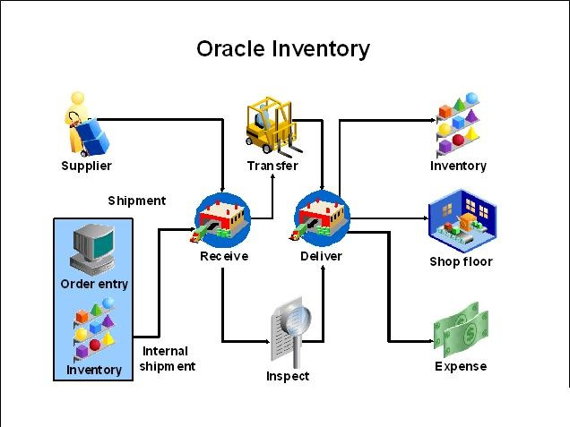

An Oracle Inventory Module is a facility where you store and transact items. Before you can use Oracle Inventory, you must define one or more inventory organizations.Replenish items internally from another sub inventory in the same organization or another organization. Supplier: Replenish items externally, from a supplier you specify in Oracle Purchasing.

# ORACLE ACCOUNTS RECEIVABLE

**Accounts receivable refers to the outstanding invoices a company has or the money the company is owed from its clients. The phrase refers to accounts a business has a right to receive because it has delivered a product or service.**[**Receivables**](https://www.investopedia.com/terms/r/receivables.asp)**essentially represent a**[**line of credit**](https://www.investopedia.com/terms/l/lineofcredit.asp)**extended by a company and due within a relatively short time period, ranging from a few days to a year.**

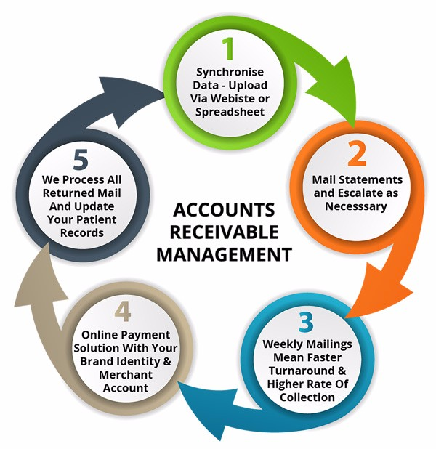

# ORACLE ACCOUNTS PAYABLES

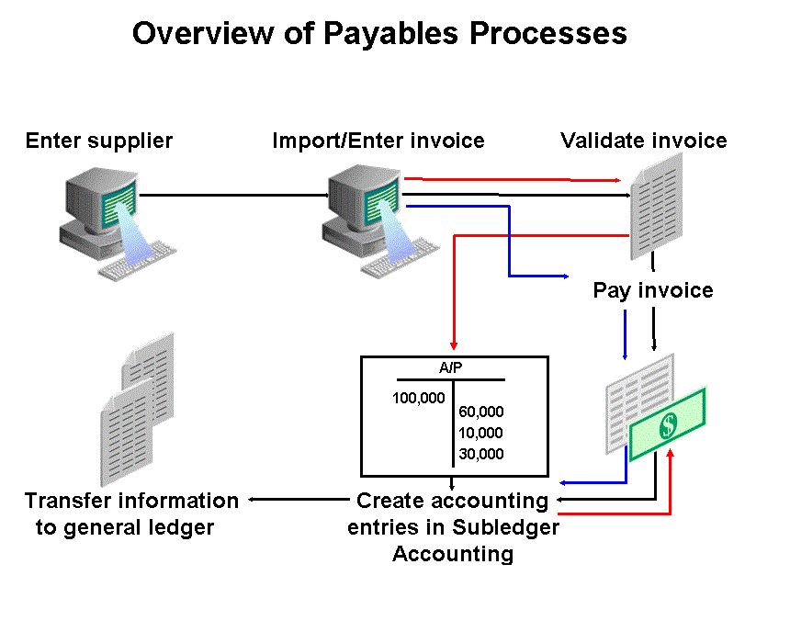

**Oracle Payables improves margins, instils corporate and fiscal discipline, and optimizes business relationships. Oracle Payables works seamlessly with other**[**Oracle E-Business Suite**](http://www.oracle.com/us/products/applications/index.html)**products to drive better decision-making, sustainable financial discipline, regulatory compliance, and optimized business processes at the lowest cost.**

# 

# ORACLE GENERAL LEDGER

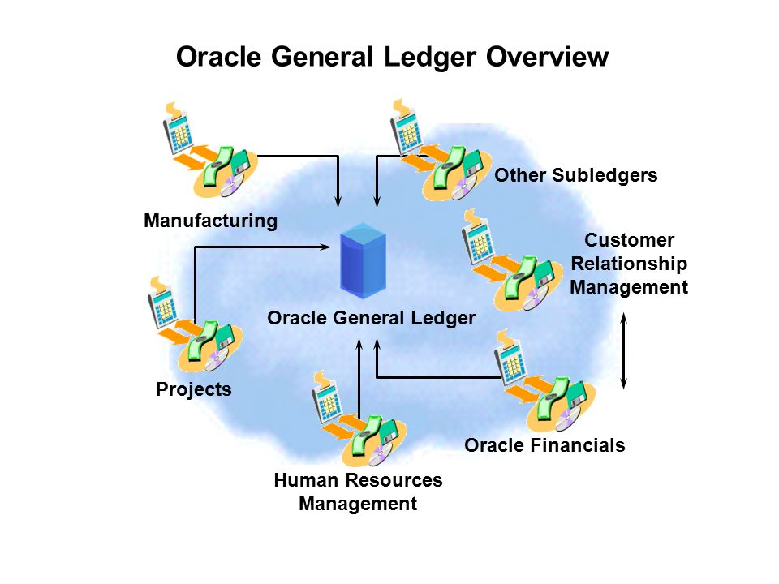

Oracle General Ledger provides highly automated financial processing. It can import and post 42 million journal lines per hour, making it the fastest and most scalable general ledger on the market. It also provides tools for effective management control and real-time visibility to financial results — everything you need to meet financial compliance and improve your bottom line.

Oracle General Ledger works seamlessly with other [Oracle E-Business Suite](http://www.oracle.com/us/products/applications/index.html) products to drive better decision-making, sustainable financial discipline, regulatory compliance, and optimized business processes at the lowest cost.

# **CURRENT PROJECT**

Currently the  IT department is working on the up gradation of oracle from version 12.1.2 to 12.2.6 which will help accommodate and use the rapid expansion of data currently at 4.2 trillion data sets to 20 trillion data sets in the next 5 years. This will also help the company to efficiently  put the data to good use.

This upgrade will be done to all the three manufacturing plants, regional offices and vendors.